Scenario 1: Student Academic Performance Dashboard
CODE:
import pandas as pd
import matplotlib.pyplot as plt

data = {
'Attendance':[75,82,90,65,95,88,70,80],
'Marks':[60,72,89,55,95,84,62,76],
'Department':['CSE','AI','IT','ECE','CSE','AI','IT','ECE']
}
df = pd.DataFrame(data)
colors = {'CSE':'red','AI':'blue','IT':'green','ECE':'orange'}
plt.figure(figsize=(6,5))

for dept in df['Department'].unique():
d = df[df['Department']==dept]
plt.scatter(d['Attendance'], d['Marks'],
color=colors[dept], label=dept, s=80)
plt.title("Student Academic Performance")
plt.xlabel("Attendance (%)")
plt.ylabel("Internal Marks")
plt.legend()
plt.grid(True)
plt.show()

OUTPUT:
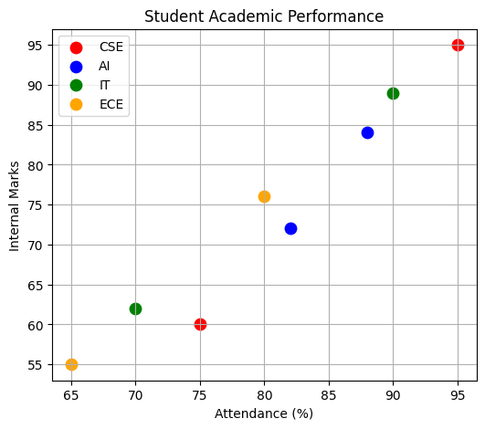

Scenario 2: Electric Vehicle Market Analysis
CODE:
import pandas as pd
import matplotlib.pyplot as plt
data = {
'Battery':[30,40,50,60,70],
'Price':[10,15,20,28,35],
'Range':[250,300,350,450,500],
'Manufacturer':['Tata','MG','Tesla','BYD','Hyundai']
}
df = pd.DataFrame(data)
plt.figure(figsize=(6,5))
plt.scatter(df['Battery'],
df['Price'],
s=df['Range'],
c=range(len(df)),
alpha=0.7)
for i in range(len(df)):
plt.text(df['Battery'][i], df['Price'][i], df['Manufacturer'][i])
plt.xlabel("Battery Capacity (kWh)")
plt.ylabel("Price (Lakhs)")
plt.title("EV Market Analysis")
plt.grid(True)
plt.show()

OUTPUT:
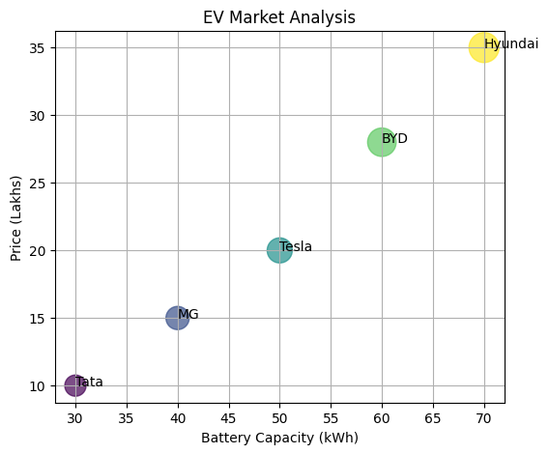
Scenario 3: Hospital Patient Admission Analysis
CODE:
import matplotlib.pyplot as plt

departments = ['Cardiology','Neurology','Orthopedic','General']
patients = [120,80,100,150]
cost = [5000,7000,6000,4000]

colors = ['red','green','blue','orange']

bars = plt.bar(departments, patients, color=colors)

for i in range(len(bars)):
plt.text(i, patients[i]+2, "₹"+str(cost[i]), ha='center')

plt.title("Hospital Admissions")
plt.xlabel("Department")
plt.ylabel("Patients")
plt.show()

OUTPUT:
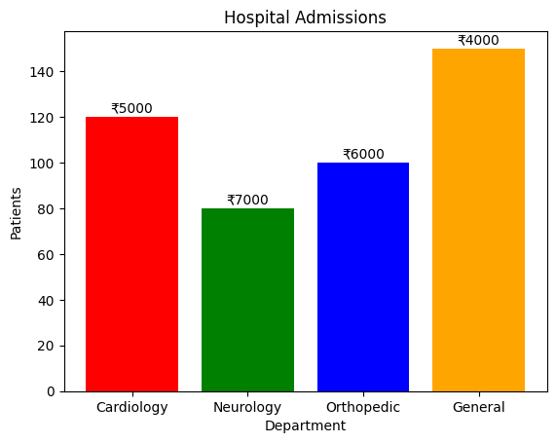
Scenario 4: Weather Monitoring System
CODE:
import matplotlib.pyplot as plt

days = [1,2,3,4,5]

city1 = [30,31,32,33,34]
city2 = [28,29,30,31,30]
city3 = [35,36,37,36,35]

plt.plot(days, city1, color='red', linestyle='-', label='Chennai')
plt.plot(days, city2, color='blue', linestyle='--', label='Bangalore')
plt.plot(days, city3, color='green', linestyle=':', label='Delhi')

plt.xlabel("Day")
plt.ylabel("Temperature")
plt.title("Temperature Trends")
plt.legend()
plt.grid(True)
plt.show()

OUTPUT:
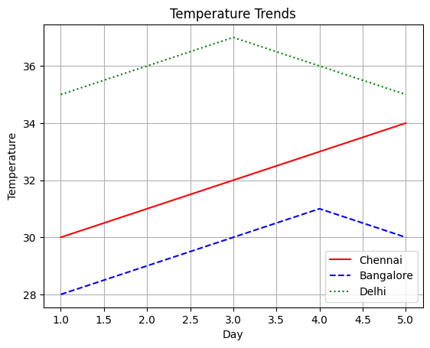
Scenario 5: Supermarket Sales Analysis
import matplotlib.pyplot as plt
import numpy as np

categories = ['Food','Drinks','Snacks']
branchA = [500,600,700]
branchB = [450,650,750]

x = np.arange(len(categories))
width = 0.35

plt.bar(x-width/2, branchA, width, label='Branch A')
plt.bar(x+width/2, branchB, width, label='Branch B')

plt.xticks(x, categories)

plt.xlabel("Product Category")
plt.ylabel("Sales")
plt.title("Sales Comparison")
plt.legend()

plt.show()

OUTPUT:
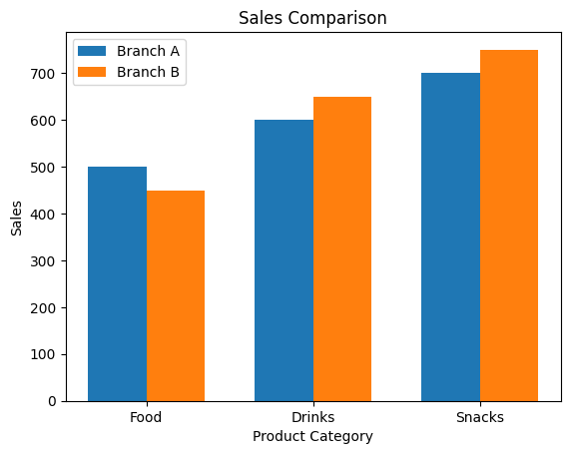
Scenario 6: Employee Salary Distribution
CODE:
import matplotlib.pyplot as plt

salary = [25000,30000,32000,35000,40000,
42000,45000,48000,50000,55000,
60000,62000,70000,75000]

plt.hist(salary, bins=5, color='skyblue', edgecolor='black')

plt.title("Salary Distribution")
plt.xlabel("Salary")
plt.ylabel("Employees")
plt.show()

OUTPUT:
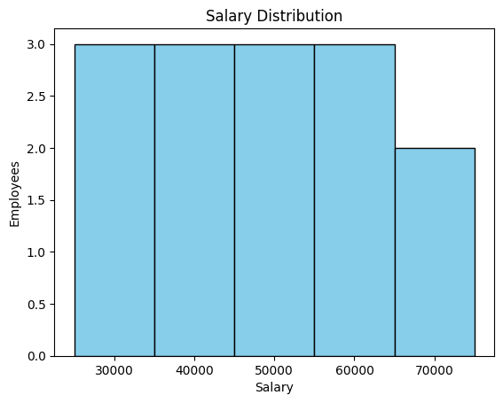

Scenario 7: Smartphone Market Comparison
CODE:
import pandas as pd
import matplotlib.pyplot as plt
data = {
'Brand':['Samsung','Apple','OnePlus','Xiaomi'],
'RAM':[8,6,12,8],
'Price':[50000,70000,55000,30000],
'Storage':[128,256,256,128],
'Processor':[2.5,3.2,3.0,2.8]
}
df = pd.DataFrame(data)
markers = ['o','s','^','D']
plt.figure(figsize=(6,5))
for i in range(len(df)):
plt.scatter(df['RAM'][i],
df['Price'][i],
s=df['Storage'][i],
c=[df['Processor'][i]],
cmap='viridis',
marker=markers[i])
plt.text(df['RAM'][i],df['Price'][i],df['Brand'][i])
plt.colorbar(label='Processor Speed')
plt.xlabel("RAM")
plt.ylabel("Price")
plt.title("Smartphone Comparison")
plt.show()

OUTPUT:
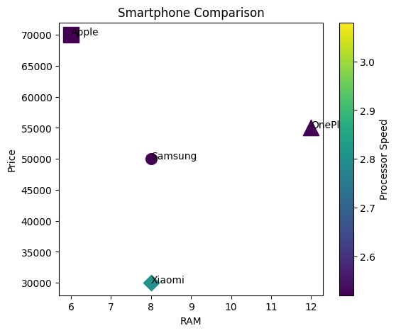
Scenario 8: Online Movie Rating Analysis
CODE:
import pandas as pd
import matplotlib.pyplot as plt

data = {
'Genre':['Action','Drama','Comedy','Horror'],
'2023':[4.1,4.5,3.8,3.9],
'2024':[4.2,4.6,4.0,3.7],
'2025':[4.3,4.8,4.2,3.8]
}

df = pd.DataFrame(data)

heat = df.set_index('Genre')

plt.imshow(heat, cmap='YlGnBu', aspect='auto')

plt.colorbar(label="Average Rating")

plt.xticks(range(3), ['2023','2024','2025'])
plt.yticks(range(4), heat.index)

plt.title("Movie Rating Heatmap")

plt.show()

OUTPUT:
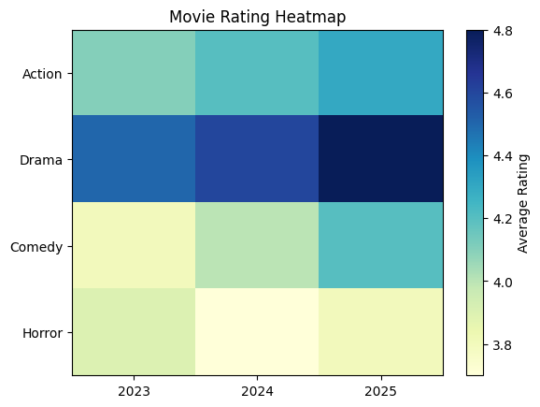
Scenario 9: COVID-19 State-wise Analysis (Tile Plot)
CODE:
import pandas as pd
import matplotlib.pyplot as plt

states = ['TN','AP','KA','KL','MH']
cases = [[1200],[1800],[900],[700],[2500]]

plt.imshow(cases, cmap='Reds', aspect='auto')

plt.yticks(range(5), states)
plt.xticks([])

plt.colorbar(label='Active Cases')

plt.title("COVID Active Cases")

plt.show()

OUTPUT:
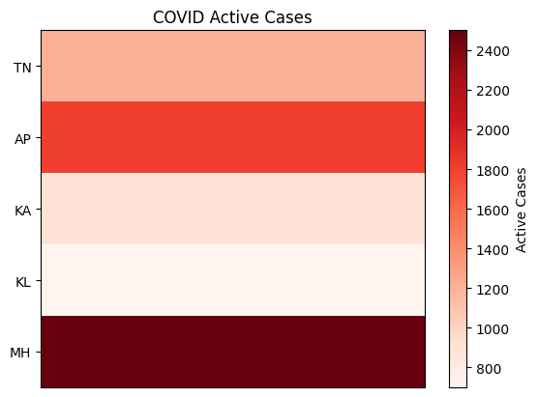

Scenario 10: Iris Flower Classification
CODE:
from sklearn.datasets import load_iris
import matplotlib.pyplot as plt
iris = load_iris()
X = iris.data
y = iris.target
markers = ['o','s','^']
colors = ['red','green','blue']
plt.figure(figsize=(7,5))
for i in range(3):
plt.scatter(
X[y==i,0], # Sepal Length
X[y==i,2], # Petal Length
s=X[y==i,1]*25, # Sepal Width
c=colors[i],
marker=markers[i],
label=iris.target_names[i] )
plt.xlabel("Sepal Length")
plt.ylabel("Petal Length")
plt.title("Iris Flower Classification")
plt.legend()
plt.show()

OUTPUT:
